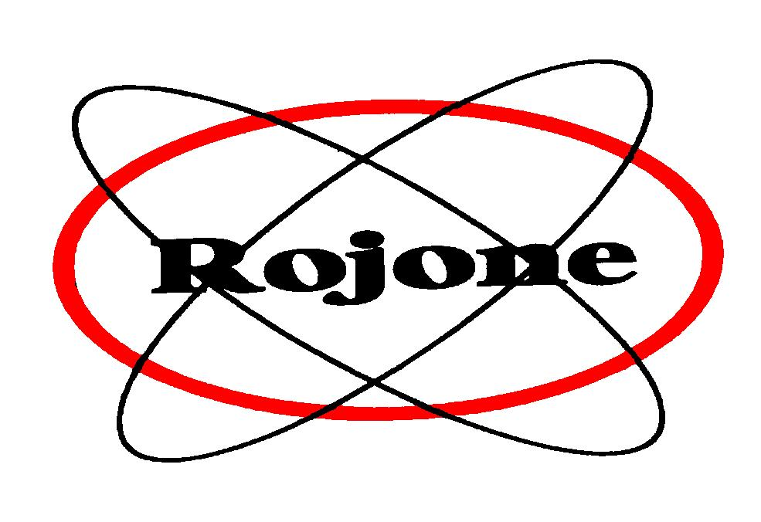
Rojone Pty. Limited

61 Aero Road Ingleburn NSW 2565 Sydney Australia ABN: 69 002 691 241
Tel +61 02 9829 1555 Fax +61 2 9829 4122
meredith@rojone.com.au www.rojone.com.au

July 31, 2026

VEHICLE PROTECTION AND MONITORING,
WITH NO ONGOING FEES

Setting a new benchmark for vehicle protection and control, an Australian designed and manufactured monitoring, protection and tracking system gives car and vehicle owners personalised, self-monitoring of their vehicle with no ongoing or back-to-base fees.

EziTrak® utilises GPS and GSM technology to give the car owner instant tampering notification, control, tracking and emergency alert information over the phone.

With EziTrak®, you are completely in control of the security of your car, with commands protected by your personal PIN code. Interaction with EziTrak® is typically done by selecting menu options over the phone (mobile phone or landline). This menu allows you to remotely immobilise the engine, lock and unlock the doors, check on your vehicle anytime, and obtain a status report including location to within 6 metres.

As a Silent Anti-theft system, EziTrak® calls its owner within seconds of a door opening or ignition detection. By selecting an option on your phone, you can instantly immobilise the engine and stop the theft. If the vehicle is removed without the ignition being started (ie towed away), you can track its removal over the phone or via GPS mapping software. When the vehicle stops moving, call the police with the exact location of the vehicle and they can retrieve it, or you can retrieve it yourself.

As a standard feature, EziTrak® also incorporates a panic button. When pressed for 2 seconds (even when the system is not activated), EziTrak® will call a nominated phone number and send a backup SMS message to alert of the incident. The coordinates provided by EziTrak® can be used by friends, family or emergency services to locate the vehicle and render assistance. Peace of mind for parents and family members.

Unlike other alarms or immobilising products, EziTrak® does not incur monitoring fees or charges; just a once-off purchase and installation cost. The only additional requirement is a GSM SIM card from your preferred network provider. EziTrak® puts control of the car back to the owner’s hands.

Left the car’s lights on? Don’t return to a useless car with a flat battery. EziTrak® will phone you when your car battery drops below a pre-set voltage level, giving you the chance to return to the vehicle and turn the lights off before the battery goes flat and you are left with a car that won’t go.

Similarly, if someone tampers with the engine and the battery, the low voltage feature will trigger and alert you instantly via a mobile phone call or SMS message. You can then immobilise the engine so that theft cannot occur.

With EziTrak®, you can remotely lock or unlock your vehicle. Imagine you have locked your keys and perhaps a child in the car and it’s a hot day! Use EziTrak® to unlock the car instantly - no need to wait for help.

Not sure if you locked the car when you left it in the shopping centre carpark? One mobile phone call to EziTrak® and you can lock your car immediately from anywhere in the world.

The EziTrak® has an internal Black Box Recorder logging speed, position, time and date from 1 to 255 hours. This information can be downloaded to your home PC and then played back on a moving map display.

Ready to install, the EziTrak® is a compact, robust module that keeps power consumption to a minimum. Installation time is typically 2 hours and can be done by the vehicle owner or a technician.

EziTrak® works through existing cellular network. It offers you security, control, GPS tracking and emergency notification all for a single one-off cost. The only additional requirement is a GSM SIM card from your preferred network provider. Mapping software is also an optional extra.

Patent protected, Rojone manufactures a range of vehicle protection systems and electronic logbooks, including;

- BikeBANDIT® to monitor and protect motorcycles
- BoatBANDIT® to monitor and protect boats
- wayLOGGERTM electronic log book for fleet and corporate use

www.ezitrak.com

MEDIA

For further information on this product or a demonstration, contact;

Peak Wireless
www.peakw.com

Meredith Cross or Livia Grabowski
Rojone Pty Ltd
61 Aero Road, Ingleburn NSW 2565
Ph 61 2 9829 1555 Fax 61 2 9829 4122
meredith@rojone.com.au www.rojone.com.au

