http://digiwave-satellite.com/pb/wp_3275ca71/wp_3275ca71.html

Triple LNB Bracket 5
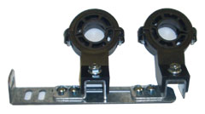This Triple LNB Bracket can connect up to 3 LNB in one dish when using one bracket.
It can connect up to 5 LNB in one dish when using two bracket.
For example: one dish can receiver 82, 91, 110, 119, 121in one dish.
$16.95 Canadian

