Infinity Reference 1230w

12" Component Subwoofer

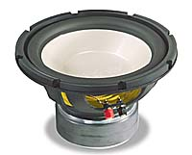
The Reference 1230w 12" component subwoofer handles up to 300 watts RMS, and is designed for use in sealed or ported boxes. You'll enjoy deep, full-bodied bass, thanks to its durable polypropylene cone, high-roll rubber surround, and structure-reinforcing inverted dustcap.
Key Features:
• polypropylene cone
• deep-draw I-beam basket
• 70-ounce magnet structure
• recommended power range 50-300 watts RMS
• peak power handling 1,200 watts
• frequency response 23-400 Hz
• sensitivity 90 dB
• top mount depth: 6-1/4"
• sealed box volume: 1.25 cu. ft.
• ported box volume: 2.00 cu. ft.
• Recommended Q-Logic Box Type: 2, 3
• 1-year warranty

